**Transient analysis of RL Circuit**

**OBJECTIVES**

* + - * RC Circuit
      * Pspice
      * RC Circuit using PSPICE

**RL Circuit:**

A circuit that contains a pure resistance R ohms connected in series with a coil having pure inductance of L (Henry) is known as**R L Series Circuit**. A first-order RL circuit is composed of one resistor and one inductor and is the simplest type of RL circuit. When an AC supply voltage V is applied, the current I flows in the circuit. IR and IL will be the voltage flowing in the resistor and inductor respectively, but the amount of current flowing through both the elements will be same as they are connected in series with each other.

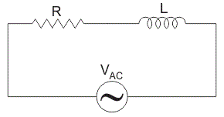

CIRCUIT DIAGRAM

**pspice:-**

The circuit file contains different functions which makes the work of an engineer more easy. One can put any sort of symbol using this software and can make different types of circuit diagrams.

**STEPS:**

* For inductor use “I”
* For switch we use “sw-tclose”
* y.PNGfor voltage maker
* Select “analysis” from menu bar
* In analysis select “setup”.
* In setup.check “transient”button.
* Click transient button
* Pop window will appear
* Check skip initial transient solution and then click “ok”
* Then, simulate graph will appear
* In graph window, there is trace button
* Click on “Add trace”
* Click on I(Li)
* **RL Circuit using PSPICE:**

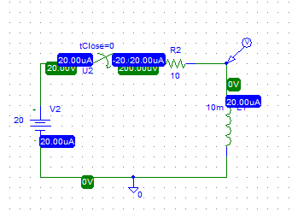

**GRAPH**

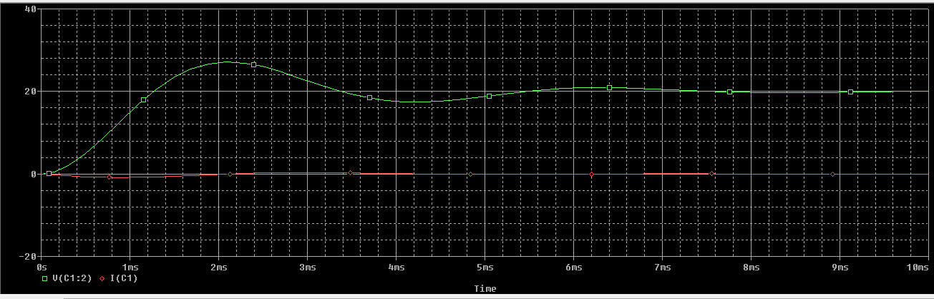

**Conclusion:**

Like the other network *analysis* procedures, we can use RL to find out the values through a particular element or elements using pspice.